- Requirement

Scissor lift base : 600x400x100 mm

Travel distance: 250 mm (0.25 m)
Slide plate : 35 mm
Screw end : 35 mm
Screw length : 322mm

Axial load : 35 + 10 = 45 Kg
Linear speed : 50 mm/sec (0.05 m/sec)

Linear accuracy: 0.5 mm (How much travel accuracy is needed ball screw itself)
Travel tolerance = 250 ± 0.5 mm

- Lead screw Calculation
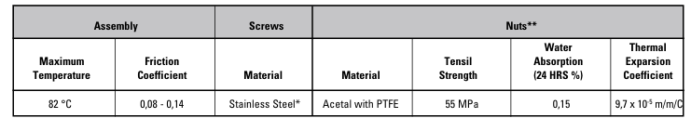

- Maximum Axial load on ball screw

Maximum load = 45 Kg + 0.65 (table)
Axial force = load * g = 45.65 Kg * 9.81 m/sec² = 447.83 N

Then Static load = 447.83 N

Dynamic load = F_{ax} +mass * a + F_{ax} * µ
F_{ax} = Axial load
µ = coefficient of fraction

from equation motion : V² = V₀² + 2ad
then, a = V / ta = 0.05 / 0.5 = 0.1 m/sec²

dynamic load (maximum load) = 447.83 + 45 * 0.05 + 0.6 * 447.83 = 721.03 N

Column Loading Capacities Chart

Use the chart below to determine the Maximum Compression Load for Screw Shaft. Usually, screws operated in tension can handle loads up to the rated capacity of the nut, providing the screw length is within standard lengths. End supports have an effect on the load capacity of screws. The four standard variations are shown below with corresponding rating adjustments. Find the point of intersecting lines of load (horizontal) and length (vertical) to determine the minimum safe diameter of screw.

Then the suitable diameter is between 8 and 10 mm

Then considering the diameter of screw = 8 mm

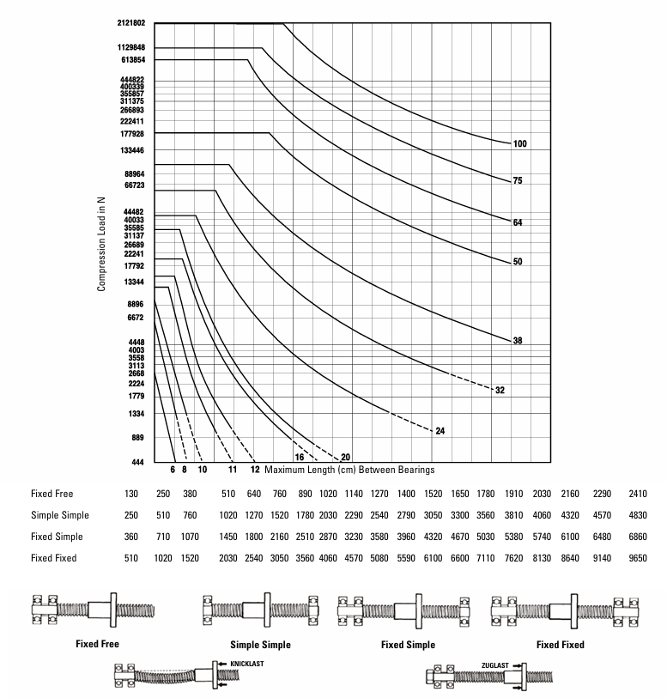

- Lead selection

Lead = V_{max} linear speed (mm/s) * 60 / N_{max} rotational speed of motor (RPM)

- length of lead screw = 322 mm
- speed of the motor
- by using stepper motor then the maximum speed is 3000 RPM
then,
lead ≥ 50*60/2000 ≥ 1.5 mm
considering lead = 2 mm
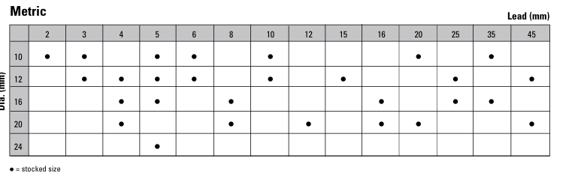
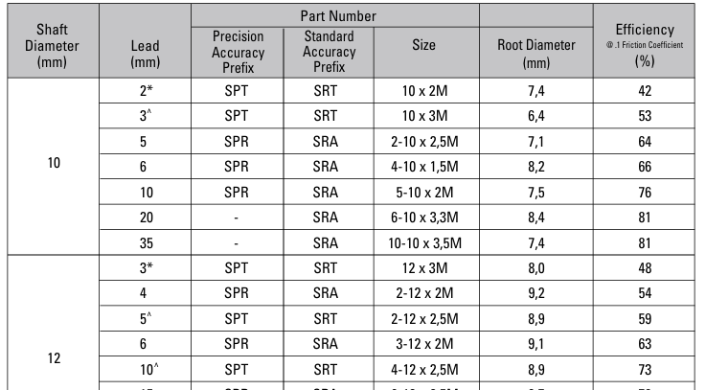

the efficiency = 42 %

- Maximum Rotational speed RPM

Every screw shaft has a rotational speed limit. That is the point at which the rotational speed sets up excessive vibration. This critical point is modified by the type of end bearing support used. To use this chart, determine the required RPM and the maximum length between bearing supports. Next, select one of the four types of end support shown below. The critical speed limit can be found by locating the point at which the RPM (horizontal lines) intersects with the unsupported screw length (vertical lines) as modified by the type of supports select below.

N_{max} = (V_{max} * 60) / lead

N_{max} = (50 * 60) / 2 = 1500 RPM

Permissible rotation speed

N_{p} > 3000 RPM

Then,
Max Rotational speed > Permissible Speed

Selection is approved

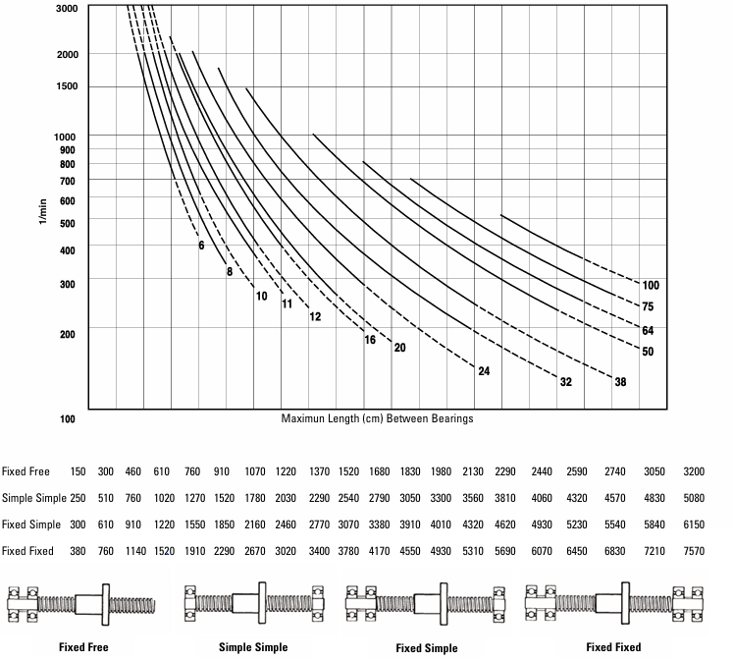

T8 lead screw [D= 8mm, L= 2mm]

